Day 55

Doubly linked list

Doubly linked list is a complex type of linked list in which a node contains a pointer to the previous as well as the next node in the sequence. Therefore, in a doubly linked list, a node consists of three parts: node data, pointer to the next node in sequence (next pointer) , pointer to the previous node (previous pointer). A sample node in a doubly linked list is shown in the figure.

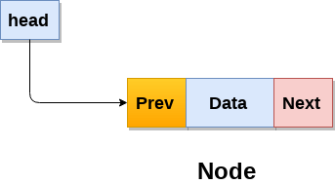

A doubly linked list containing three nodes having numbers from 1 to 3 in their data part, is shown in the following image.

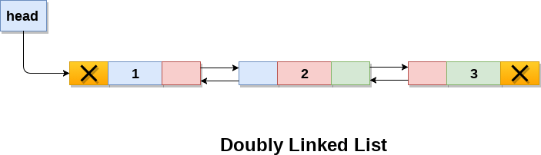

In C, structure of a node in doubly linked list can be given as :

1. struct node
2. {
3. struct node *prev;
4. **int** data;
5. struct node *next;
6. }

The **prev** part of the first node and the **next** part of the last node will always contain null indicating end in each direction.

In a singly linked list, we could traverse only in one direction, because each node contains address of the next node and it doesn't have any record of its previous nodes. However, doubly linked list overcome this limitation of singly linked list. Due to the fact that, each node of the list contains the address of its previous node, we can find all the details about the previous node as well by using the previous address stored inside the previous part of each node.

Memory Representation of a doubly linked list

Memory Representation of a doubly linked list is shown in the following image. Generally, doubly linked list consumes more space for every node and therefore, causes more expansive basic operations such as insertion and deletion. However, we can easily manipulate the elements of the list since the list maintains pointers in both the directions (forward and backward).

In the following image, the first element of the list that is i.e. 13 stored at address 1. The head pointer points to the starting address 1. Since this is the first element being added to the list therefore the **prev** of the list **contains** null. The next node of the list resides at address 4 therefore the first node contains 4 in its next pointer.

We can traverse the list in this way until we find any node containing null or -1 in its next part.

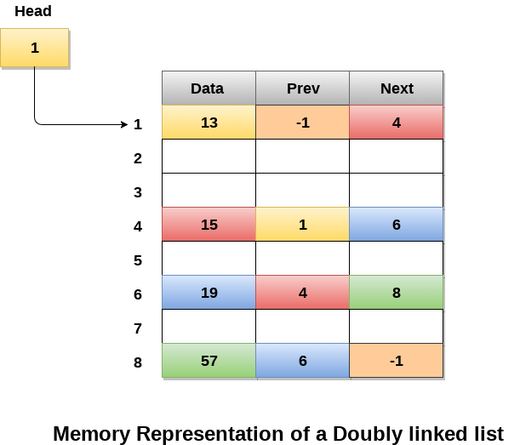

Operations on doubly linked list

**Node Creation**

1. struct node
2. {
3. struct node *prev;
4. **int** data;
5. struct node *next;
6. };
7. struct node *head;

All the remaining operations regarding doubly linked list are described in the following table.

|  |  |  |
| --- | --- | --- |
| **SN** | **Operation** | **Description** |
| 1 | [Insertion at beginning](https://www.javatpoint.com/insertion-in-doubly-linked-list-at-beginning) | Adding the node into the linked list at beginning. |
| 2 | [Insertion at end](https://www.javatpoint.com/insertion-in-doubly-linked-list-at-the-end) | Adding the node into the linked list to the end. |
| 3 | [Insertion after specified node](https://www.javatpoint.com/insertion-in-doubly-linked-list-after-specified-node) | Adding the node into the linked list after the specified node. |
| 4 | [Deletion at beginning](https://www.javatpoint.com/deletion-in-doubly-linked-list-at-beginning) | Removing the node from beginning of the list |
| 5 | [Deletion at the end](https://www.javatpoint.com/deletion-in-doubly-linked-list-at-the-end) | Removing the node from end of the list. |
| 6 | [Deletion of the node having given data](https://www.javatpoint.com/deletion-in-doubly-linked-list-after-the-specified-node) | Removing the node which is present just after the node containing the given data. |
| 7 | [Searching](https://www.javatpoint.com/searching-in-doubly-linked-list) | Comparing each node data with the item to be searched and return the location of the item in the list if the item found else return null. |
| 8 | [Traversing](https://www.javatpoint.com/traversing-in-doubly-linked-list) | Visiting each node of the list at least once in order to perform some specific operation like searching, sorting, display, etc. |

## Java program to search an element in a doubly linked list

In this program, we need to search a given node in a doubly linked list.

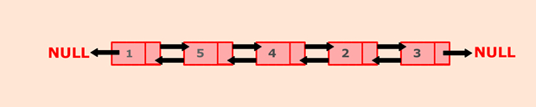

To solve this problem, we will traverse through the list using a node current. Current points to head and start comparing searched node data with current node data. If they are equal, set the flag to true and print the message along with the position of the searched node.

For eg., In above list, a search node says 4 can be found at the position 3.

### **Algorithm**

* Define a Node class which represents a node in the list. It will have three properties: data, previous which will point to the previous node and next which will point to the next node.
* Define another class for creating a doubly linked list, and it has two nodes: head and tail. Initially, head and tail will point to null.
* addNode() will add node to the list:
  + It first checks whether the head is null, then it will insert the node as the head.
  + Both head and tail will point to a newly added node.
  + Head's previous pointer will point to null and tail's next pointer will point to null.
  + If the head is not null, the new node will be inserted at the end of the list such that new node's previous pointer will point to tail.
  + The new node will become the new tail. Tail's next pointer will point to null.

a. searchNode() will search for a node in the list:

* Variable i will keep track of the position of the searched node.
* The variable flag will store boolean value false.
* Current will point to head node.
* Iterate through the loop by incrementing current to current.next and i to i + 1.
* Compare each node's data with the searched node. If a match is found, set flag to true.
* If the flag is true, prints the position of the searched node.
* Else, print the message "Element is not present in the list".